**3b. Contradictory Promises: Primary Source Analysis**

**Source A**

**Sykes-Picot Agreement, 1916**

*An agreement between Britain and France to divide the territories of the Ottoman Empire between them after the war, with Britain getting Palestine-Israel*

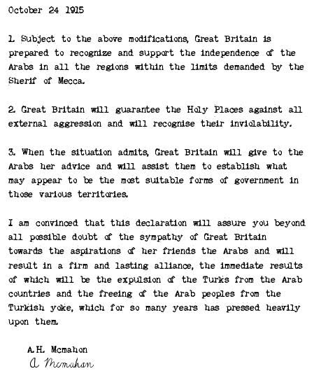

**Source B**

**Hussein-McMahon Correspondence, 1916**

*The British Government promised the Arabs that if they revolted against the Ottoman Empire, Britain would recognise an independent Arab state after the war*

**Source C**

**Balfour Declaration, November 1917** *promised the British Government’s support for a ‘national home’ for the Jews in Palestine-Israel*

